* **Installing IDE**

1. Create a folder in C:/Users/Username named workspaces.

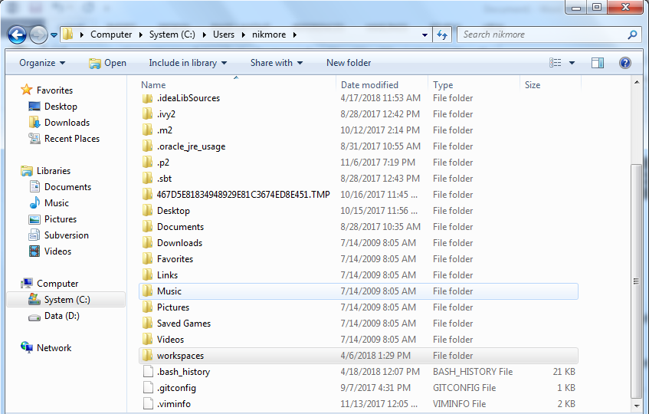

1. Create your project inside the workspaces folder.

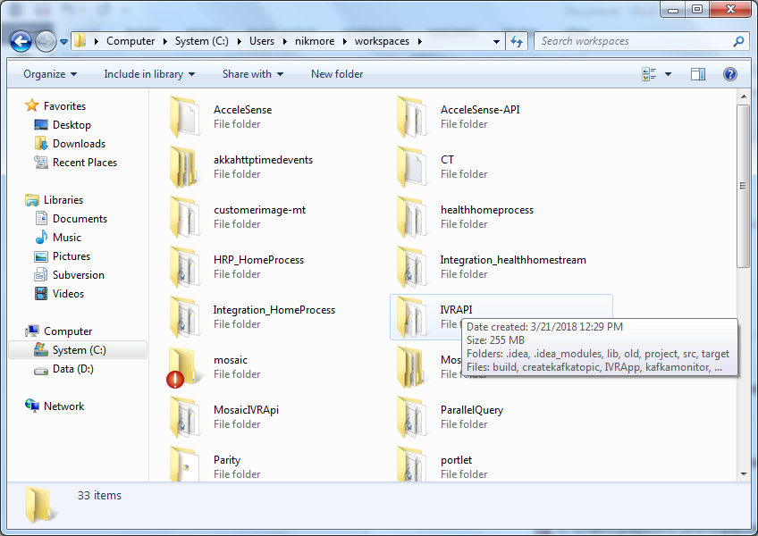

1. Create a package in C:/Users/Username workspaces/ProjectName/src/main/scala
2. Note: Follow the same project structure as mentioned above.
3. Keep the setpath.bat and runintellij.bat inside your project folder.
4. Create a software folder in workspaces and keep all your software’s inside it.

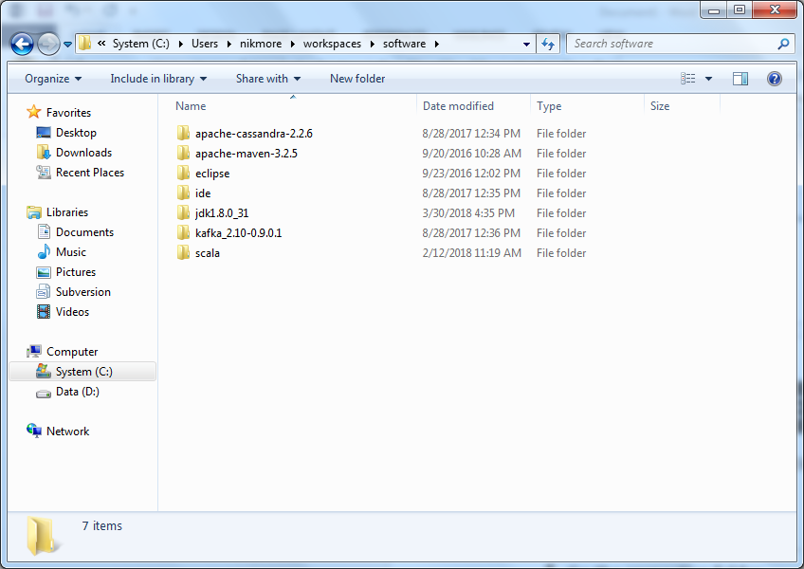

1. To start the IDE go to the command prompt.
2. Go to the respective folder.

Eg. C:\Users\nikmore\workspaces\IVRAPI>

1. Call the runintellij.bat

Eg: C:\Users\nikmore\workspaces\IVRAPI> runintellij.bat

1. You can now start writing your code.

* **Running Scala Program in CMD.**

1. Create .scala file in your projects and write your code in that file(eg:abc.scala )
2. In your respective projects open CMD window and run setpath.bat.
3. Run command scala abc.scala.